Table of Contents

Context .................................................................................................................. 2

Objective ............................................................................................................... 2

Data Description .................................................................................................... 2

Data Dictionary: ................................................................................................. 2

Rubrics .................................................................................................................. 5

Exploratory Data Analysis ...................................................................................... 5

Data Preprocessing ............................................................................................... 9

Model Building ..................................................................................................... 10

Model Performance Improvement ........................................................................ 10

Model Performance Comparison and Final Model Selection ................................ 11

Actionable Insights & Recommendations ............................................................. 11

Context

A significant number of hotel bookings are called off due to cancellations or no-shows. The typical reasons for cancellations include change of plans, scheduling conflicts, etc. This is often made easier by the option to do so free of charge or preferably at a low cost which is beneficial to hotel guests but it is a less desirable and possibly revenue-diminishing factor for hotels to deal with. Such losses are particularly high on last-minute cancellations.

The new technologies involving online booking channels have dramatically changed customers’ booking possibilities and behavior. This adds a further dimension to the challenge of how hotels handle cancellations, which are no longer limited to traditional booking and guest characteristics.

The cancellation of bookings impact a hotel on various fronts:
1. Loss of resources (revenue) when the hotel cannot resell the room.
2. Additional costs of distribution channels by increasing commissions or paying for publicity to help sell these rooms.
3. Lowering prices last minute, so the hotel can resell a room, resulting in reducing the profit margin.
4. Human resources to make arrangements for the guests.

Objective

The increasing number of cancellations calls for a Machine Learning based solution that can help in predicting which booking is likely to be canceled. INN Hotels Group has a chain of hotels in Portugal, they are facing problems with the high number of booking cancellations and have reached out to your firm for data-driven solutions. You as a data scientist have to analyze the data provided to find which factors have a high influence on booking cancellations, build a predictive model that can predict which booking is going to be canceled in advance, and help in formulating profitable policies for cancellations and refunds.

Data Description

The data contains the different attributes of customers' booking details. The detailed data dictionary is given below.

Data Dictionary:

Booking_ID: the unique identifier of each booking

no_of_adults: Number of adults

no_of_children: Number of Children

no_of_weekend_nights: Number of weekend nights (Saturday or Sunday) the guest stayed or booked to stay at the hotel

no_of_week_nights: Number of weeknights (Monday to Friday) the guest stayed or booked to stay at the hotel

type_of_meal_plan: Type of meal plan booked by the customer:

Not Selected – No meal plan selected

Meal Plan 1 – Breakfast

Meal Plan 2 – Half board (breakfast and one other meal)

Meal Plan 3 – Full board (breakfast, lunch, and dinner)

required_car_parking_space: Does the customer require a car parking space? (0 - No, 1- Yes)

room_type_reserved: Type of room reserved by the customer. The values are ciphered (encoded) by INN Hotels Group

lead_time: Number of days between the date of booking and the arrival date

arrival_year: Year of arrival date

arrival_month: Month of arrival date

arrival_date: Date of the month

market_segment_type: Market segment designation.

repeated_guest: Is the customer a repeated guest? (0 - No, 1- Yes)

no_of_previous_cancellations: Number of previous bookings that were canceled by the customer prior to the current booking

no_of_previous_bookings_not_canceled: Number of previous bookings not canceled by the customer prior to the current booking

avg_price_per_room: Average price per day of the reservation; prices of the rooms are dynamic. (in euros)

no_of_special_requests: Total number of special requests made by the customer (e.g. high floor, view from the room, etc)

booking_status: Flag indicating if the booking was canceled or not.

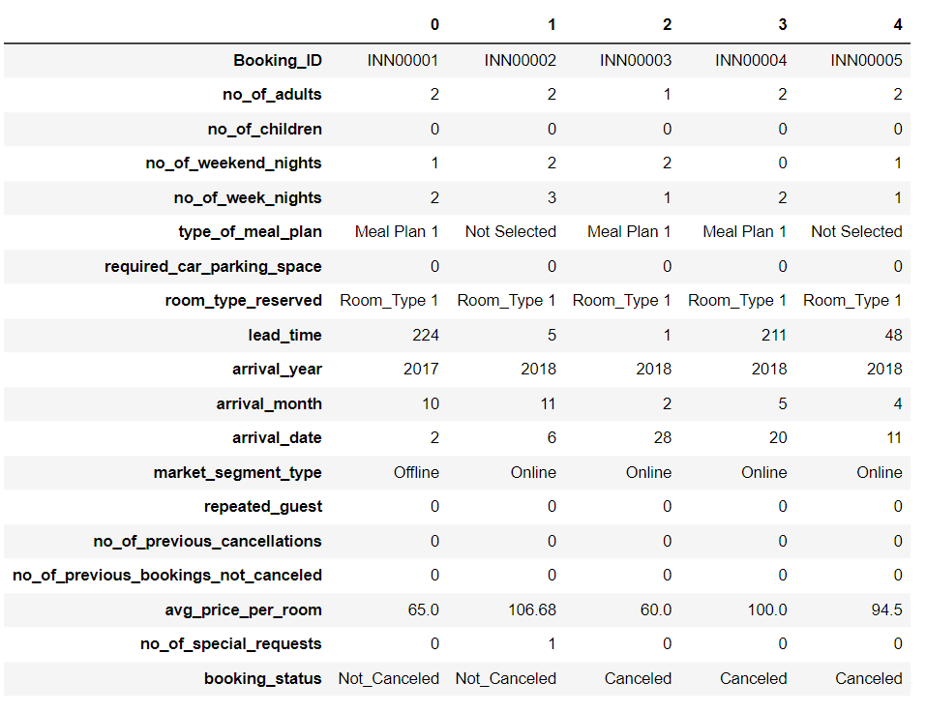

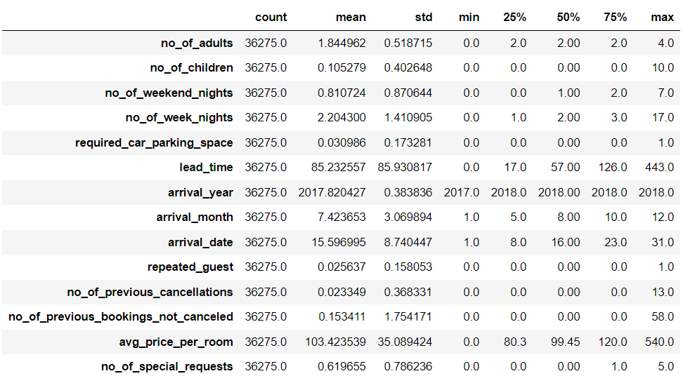

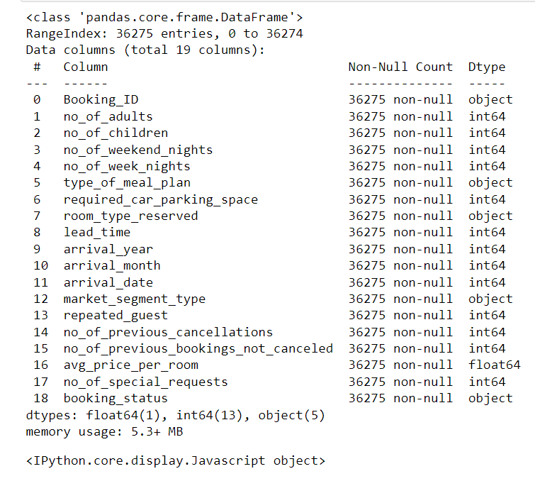

The Data Structure contains a mix of numerical and categorical data, with a focus on booking information, customer details, and room preferences. The data can be used for analysis and modelling to predict booking cancellations, optimize pricing, and improve customer satisfaction.

• The Dataset has been loaded properly.

• Booking_ID: A unique identifier for each booking, represented as a string

. • no_of_adults: The number of adults in the booking, represented as an integer.

• no_of_children: The number of children in the booking, represented as an integer.

• no_of_weekend_nights: The number of weekend nights booked, representted as an integer.

• no_of_week_nights: The number of weeknights booked, represented as an integer.

• type_of_meal_plan: The type of meal plan chosen, represented as a categorical string (e.g., "Meal Plan 1", "Not Selected").

• required_car_parking_space: A binary indicator (0 or 1) representing whether a car parking space is required.

• room_type_reserved: The type of room reserved, represented as a categorical string (e.g., "Room_Type 1").

• lead_time: The number of days between booking and arrival, represented as an integer.

• arrival_year: The year of arrival, represented as an integer.

• arrival_month: The month of arrival, represented as an integer.

• arrival_date: The day of arrival, represented as an integer.

• market_segment_type: The market segment type, represented as a categorical string (e.g., "Offline", "Online").

• repeated_guest: A binary indicator (0 or 1) representing whether the guest is a repeat customer.

• no_of_previous_cancellations: The number of previous cancellations, represented as an integer.

• no_of_previous_bookings_not_canceled: The number of previous bookings not canceled, represented as an integer.

• avg_price_per_room: The average price per room, represented as a floating-point number.

• no_of_special_requests: The number of special requests, represented as an integer.

• booking_status: The status of the booking (e.g., "Not_Canceled", "Canceled"), represented as a categorical string.

Data Types

The data types of each column are: Integer: no_of_adults, no_of_children, no_of_weekend_nights, no_of_week_nights, lead_time, arrival_year, arrival_month, arrival_date, no_of_previous_cancellations, no_of_previous_bookings_not_canceled, no_of_special_requests

String: Booking_ID, type_of_meal_plan, room_type_reserved, market_segment_type, booking_status

Binary: required_car_parking_space, repeated_guest

Floating-point: avg_price_per_room

INN Hotel Group Rubrics –

Problem Statement 1. Exploratory Data Analysis - Problem definition - Univariate analysis - Bivariate analysis - Use appropriate visualizations to identify the patterns and insights - Answers to EDA questions provided - Key meaningful observations on individual variables and the relationship between variables

The below EDA section of the report will provide an overview of the data distribution and relationships between variables. The plots and statistics generated in this section will help to identify the patterns, outliers, and correlations in the data.

Important Note: The following questions need to be answered as a part of the EDA section of the project:

What are the busiest months in the hotel?

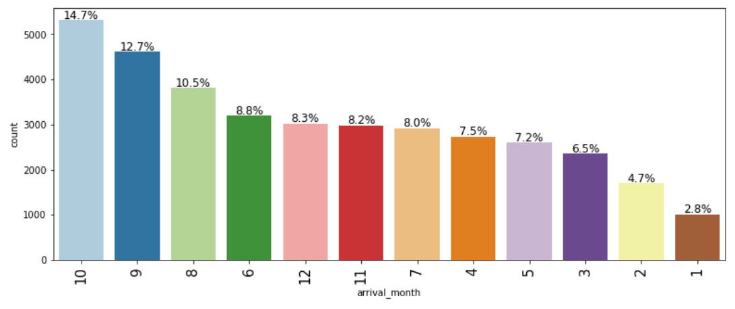

Observations:
- The busiest month is October.
- The later the months the busier the hotel seems to be.
- This could be due to people having to see their families for the holidays, or an attempt to use all their vacation days before they run out for the new year.

Which market segment do most of the guests come from?

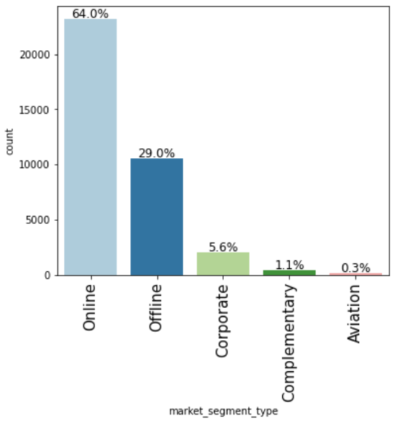

Observations:
- 64% of the guests come from reservations made online.
- 29% of guest come from reservations made offline.
- Corporate, Complimentary, and Aviation combine for about 7% of the rest of the reservations.
- Online seems to be the biggest market segment by far. Increasing online presence may increase reservations.

Hotel rates are dynamic and change according to demand and customer demographics. What are the differences in room prices in different market segments?

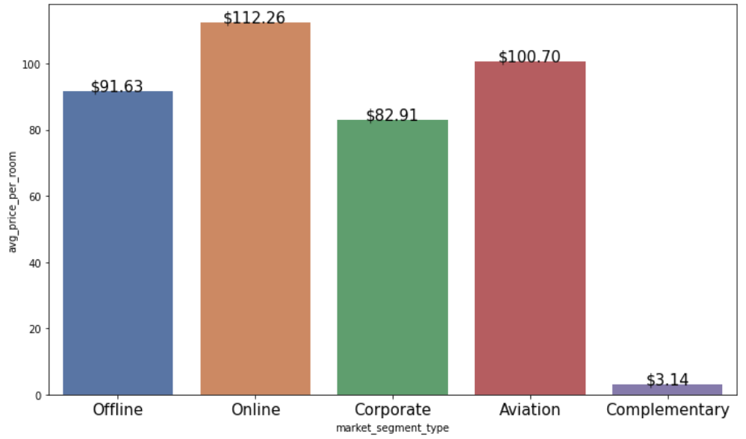

Observations:
- Complimentary seems negligible in this column since they are free rooms. The $3 must be for room service and other such fees.
- Online is the most expensive market, since it is also the most popular that would make sense.
- Corporate is the cheapest, they must have deals worked out since they have multiple repeat employees traveling for work regularly.

What percentage of bookings are cancelled?

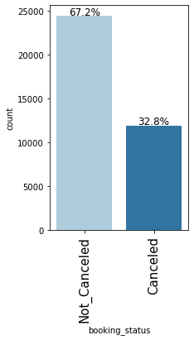

Observations:

- About 32.8% of bookings are canceled.

- 32.8% seems quite high.

Repeating guests are the guests who stay in the hotel often and are important to brand equity.

What percentage of repeating guests cancel?

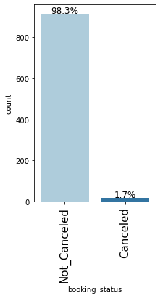

Observations:

- The number of cancelations drastically decreases when the guests are repeat guests.

- It changes from 32.8% to 1.7%

- Repeat customers definitely effect booking status.

Many guests have special requirements when booking a hotel room. Do these requirements affect booking cancelation?

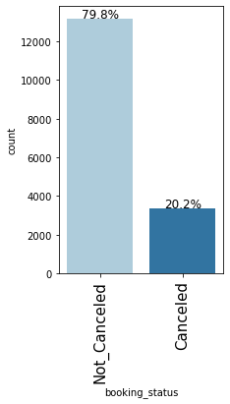
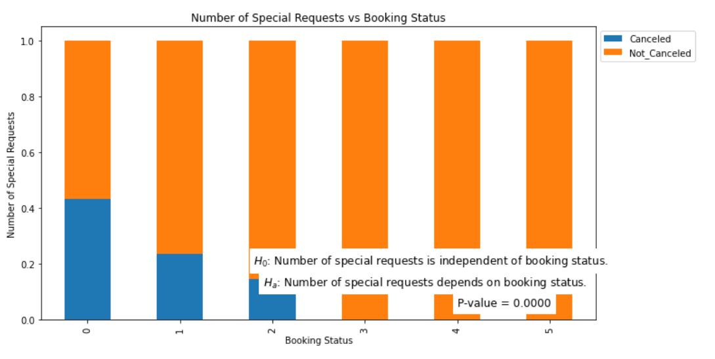

Many guests have special requirements when booking a hotel room. Do these requirements affect booking cancellation? 79.8% of bookings were not cancelled while 20.2% were cancelled. However, there is a dramatic shift in the proportion of cancellations. 98.3% of bookings were not cancelled, while only 1.7% were cancelled for repeating guests.

Customer Demographics and Cancellation: 1. How does the number of adults and children in a booking influence the probability of cancellation?

Data Preprocessing –

Missing Value Treatment (with rationale if needed) – Outlier Detection and Treatment (with rationale if needed) – Feature Engineering (with rationale if needed) – Data Scaling (with rationale if needed) – Train-test split

Data Preprocessing includes the data for modelling by:

• Checking for duplicates.

• Checking for missing values.

• Encoding categorical variables using one-hot encoding

Duplicate Value Check:

No Duplicates are found in the given dataset.

Missing Value Treatment:

No Missing values are found in the given dataset.

Feature Engineering: We have done the encoding for categorical variables using one-hot encoding. Creating new features if necessary (example: total_nights)

Exploratory Data Analysis (EDA)
- EDA is an important part of any project involving data.
- It is important to investigate and understand the data better before building a model with it.
- A few questions have been mentioned below which will help you approach the analysis in the right manner and generate insights from the data.
- A thorough analysis of the data, in addition to the questions mentioned below, should be done.

Univariate Analysis
Refer Jupyter Notebook
No. of Adult

Observations:
- Majority of the data is with 2 adults. The outliers do not need to be treated since they’re possible, yet not likely.
- It is understandable that there are usually 2 adults and couples are more likely to take trips together.
No. of children

Observations:
- Majority of the data is with 0 children. The outliers need to be treated for the values past 8 since they're highly unlikely and so small in occurrence that deleting them will not affect the data.

Number of Weekend Nights

Observations:
- Outliers are present, may need to treat outliers, but data seems needed as is, and so I will probably leave it.

Required Car Parking Space

Observations:
- Required car parking space is a boolean value, so there are no outliers, and no action is needed. It is good to note that almost all the time parking is not required.

Arrival Year

Observations:
- The data is comprised of only two years, 2017 and 2018. 2018 is the year the majority of the bookings were made.
- No outlier treatment needed.

Arrival Month

Observations:
- Arrival month seems almost evenly spread out, which causes there to be no outliers.
- October is the most popular month for booking arrivals.
- The later/cooler months are the most popular.

Arrival Date

Observations:
- Arrival date is evenly spread throughout the days. There is no real pattern discerning which of the days has the most bookings.

Repeated Guest

Observations:
- boolean values giving True or False statement for if a customer is a repeating guest or not.
- Majority of the guests are 1 time customers.

Number of Previous Cancellations

Observations:
- Number of previous cancellations counts the amount of cancellations made by previously by the guest booking the reservation.
- There are obvious outliers past 10 that may need to be treated.
- The heavy majority of bookings have not previously cancelled a reservation.

Number of Previous Bookings Not Canceled

Observations:
- 0 is the heavy majority for the number of previous bookings that were not canceled.
- Outliers are present but will probably not be treated

Average Price Per Room

Observations:
- Average price per room is normally are about $100
- There were quite a bit of bookings for $0, this will have to be looked into as free bookings seem too common.

Number of Special Requests

Observations:
- Outliers do not seem abnormal.
- Most of the time no one submits a special request.

Bivariate Analysis

Refer Jupyter notebook

Booking Status vs Number of Adults

Observations:¶
- The booking status is more for non-canceled than canceled. The status is not dependent on the amount of adults.

Booking Status vs Number of Children

Observations:
- 0 is the most popular amount of children, meaning between that and the number of adults, it is safe to assume most reservations are either business associates sharing a room or couples with no children. There is no relationship between no_of_children and booking status.

Booking Status vs Number of Weekend Nights

Observations:
- It seems safe to say that the greater the number of weekend nights that are reserved the greater the chance will be that a reservation is canceled.

Booking Status vs Number of Week Nights

Observations:
- It is safe to sat that the greater the number of week nights that are reserved the greater the chance will be that a reservation is canceled. Between this graph and the previous graph for number of weekend nights, it is safe to assume the greater the number of total nights reserved, the greater the chance that a reservation will be canceled.

Booking Status vs Type of Meal Plan

Observations:
- The type of meal plan does seem to have a slight change in the cancellation status, keep in mind the meal plan type is not indicative of a quantitative amount of meal plan. It is simply an indicator. However, since the 3rd meal plan is the most extravagant and assuming expensive it does make sense that this would require the smallest rate of cancellations for all of the meal plans.

Booking Status vs Required Car Parking Space

Observations:
- The amount of data points showing that if a car parking space is required is small compared to the total amount of data points, however it does seem to show that if a parking spot is required by the customer then it is almost 90% certain that the customer will not cancel.

Booking Status vs Room Type Reserved

Observations:
- The type of room does seem to have a slight change in the cancellation status, keep in mind the room type is not indicative of a quantitative amount of room types. It is simply an indicator.

Booking Status vs Arrival Year

Observations:
- It seems that there were much less cancellations in 2017 then compared to 2018. Difference being from about 85% in 2017 to about 63% in 2018. This seems to be a sharp drop in rate of cancellations.

Booking Status vs Arrival Month

Observations:
- It seems that the colder winter months have less of a chance of cancellation then compared to the warmer summer months.

Booking Status vs Market Segment Type

Observations:
- Complementary has no cancellations which makes sense since it is a free trip for the customer. Corporate is second which also makes sense since these reservations are for business trips, and must be attended. These are also typically paid for by the company and not the employee staying in the room. Seeing how little the amount of corporate reservations there are, it is safe to believe that the majority of the reservations are from couples with no children.

Booking Status vs Repeated Guest

Observations:
- There seems to be a correlation between a guest be a repeating guest and a guest not canceling. This makes sense as loyal customers seem to come back. I am sure with membership discounts and rewards the incentive to not cancel is too much.

Booking Status vs Number of Previous Cancellations

Observations:
- The number of cancellations seems to go down drastically after the number of previous cancellations goes beyond 0. The incentive to not repeat cancel seems to high to reject. The 13 seems to be an outlier that should be removed, since the 4 occurrences of this value have all the exact same feature values for all data points. Thus, these four occurrences should be removed. A person who has previously canceled is sure to book a reservation 96% of the time.

Booking Status vs Number of Previous Bookings not Canceled

Observations:
- Any guest who has not canceled almost guarantees a guest will not cancel, thus it should be treated as a premium reward for the business to target. A person who has not previously canceled a reservation has a 99.6% change of not canceling.

Booking Status vs Number of Special Requests

Observations:
- As the number of special requests rises the number of cancellations decreases. This makes sense as the number of special request that increase means the customer is more picky and less likely/willing to cancel since all their needs are being met.

Data Preprocessing
- Missing value treatment (if needed)
- Feature engineering (if needed)
- Outlier detection and treatment (if needed)
- Preparing data for modeling
- Any other preprocessing steps (if needed)

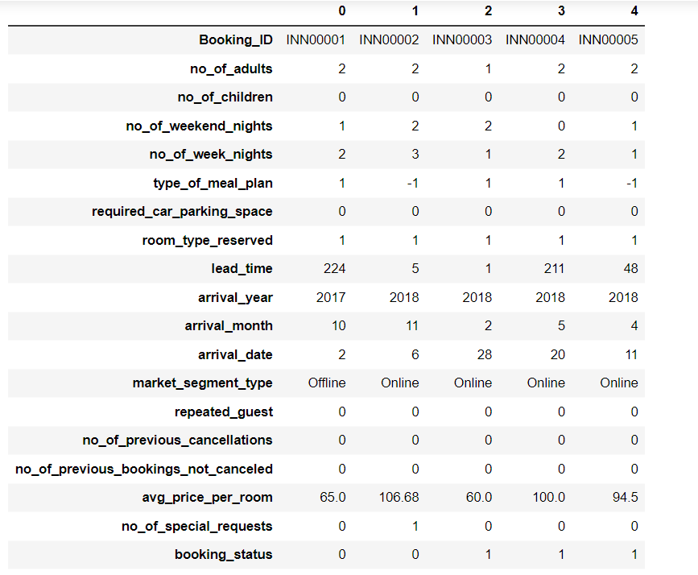

Treating Outliers
- Lead time
- Avg price per room

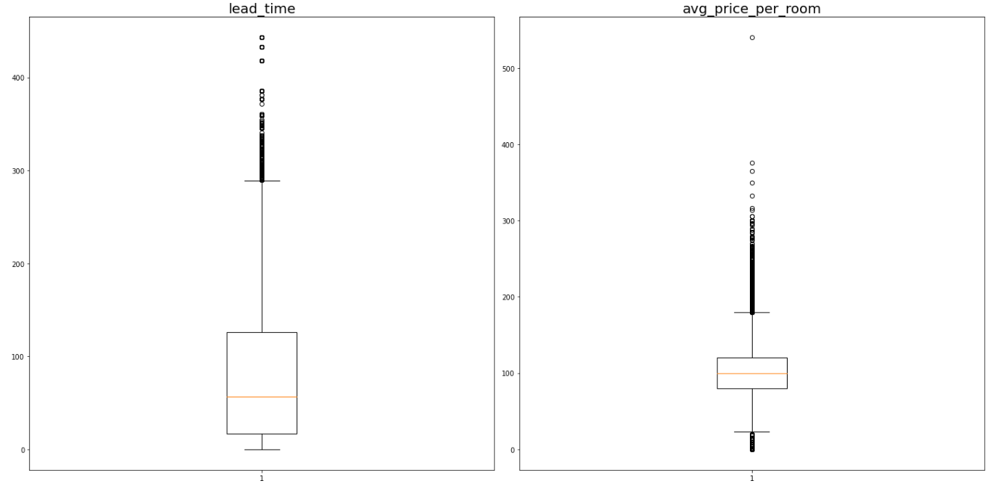

Number of Children

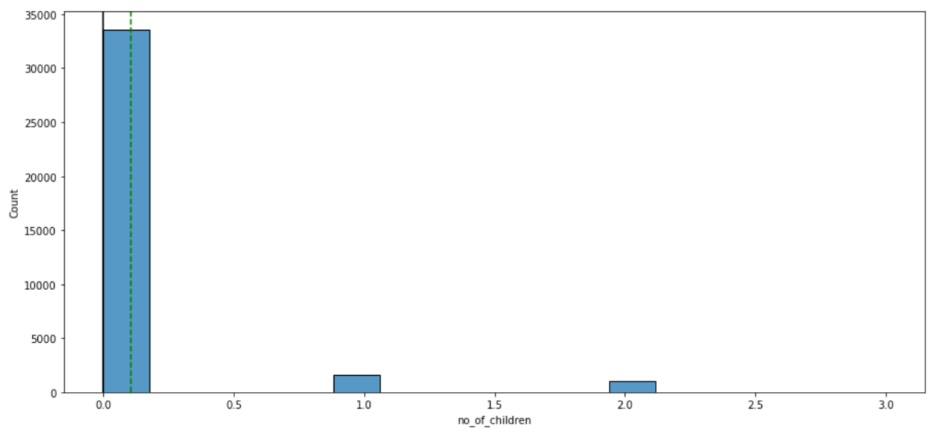
Observations: - The number of children are normally 0. This with the combination of the number of adults usually being 2, it is safe to assume that most reservations are made by couples needing a get away.\n - No normal distribution or need to remove outliers."}]

Type of Meal Plan
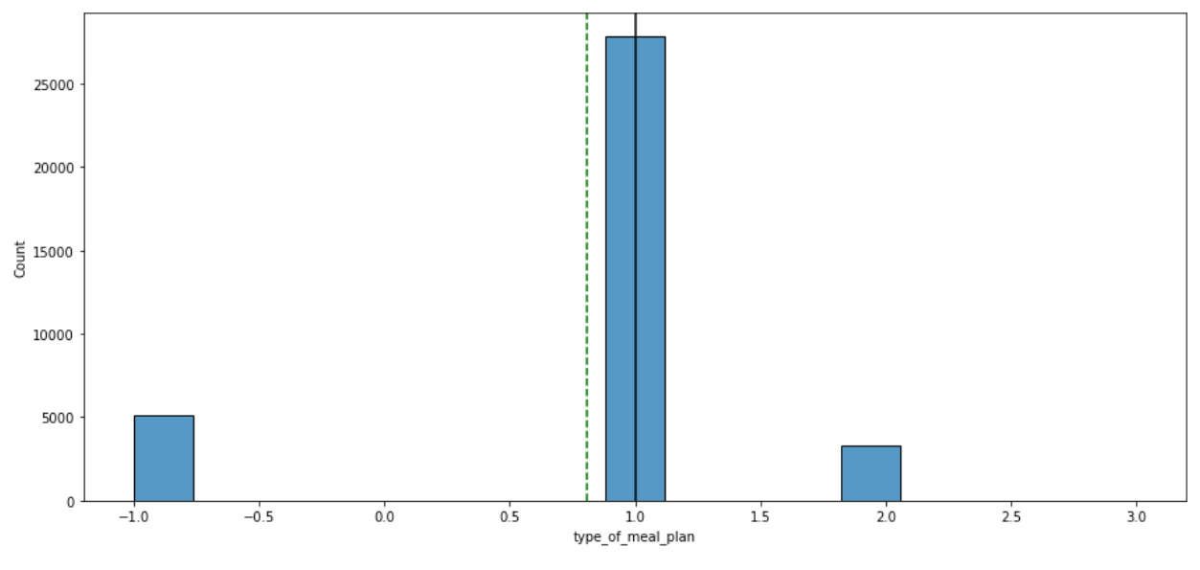

Observations:
- The most popular meal plan is 1, which is also the worst and cheapest meal plan.
- No normal distribution or need to remove outliers.

Room Type Reserved
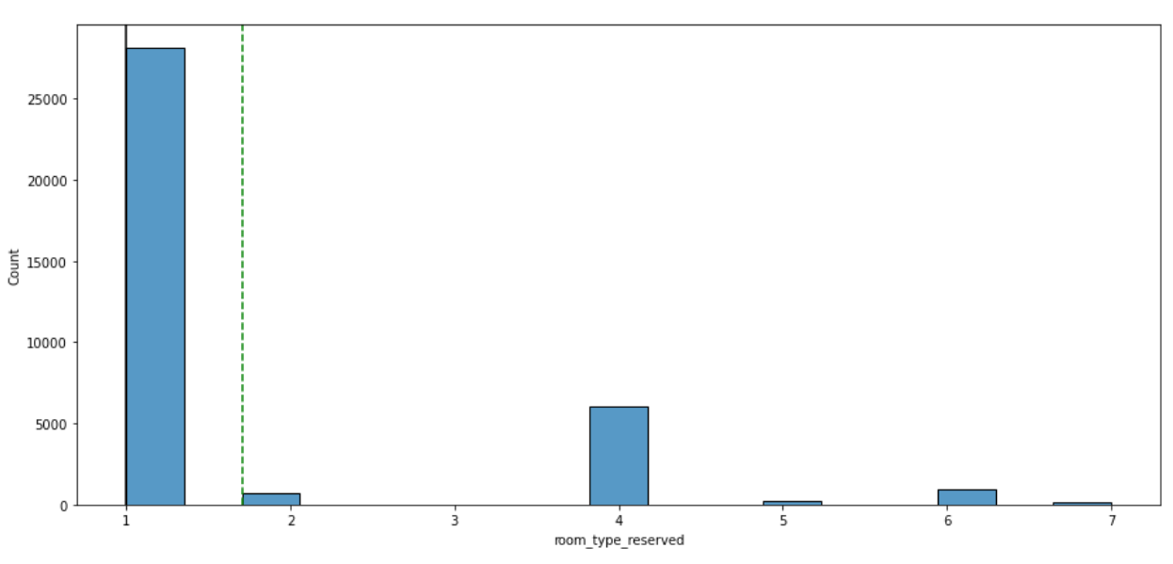

Observations:
- The most popular room type reserved is 1.
- No normal distribution or need to remove outliers.

Booking Status
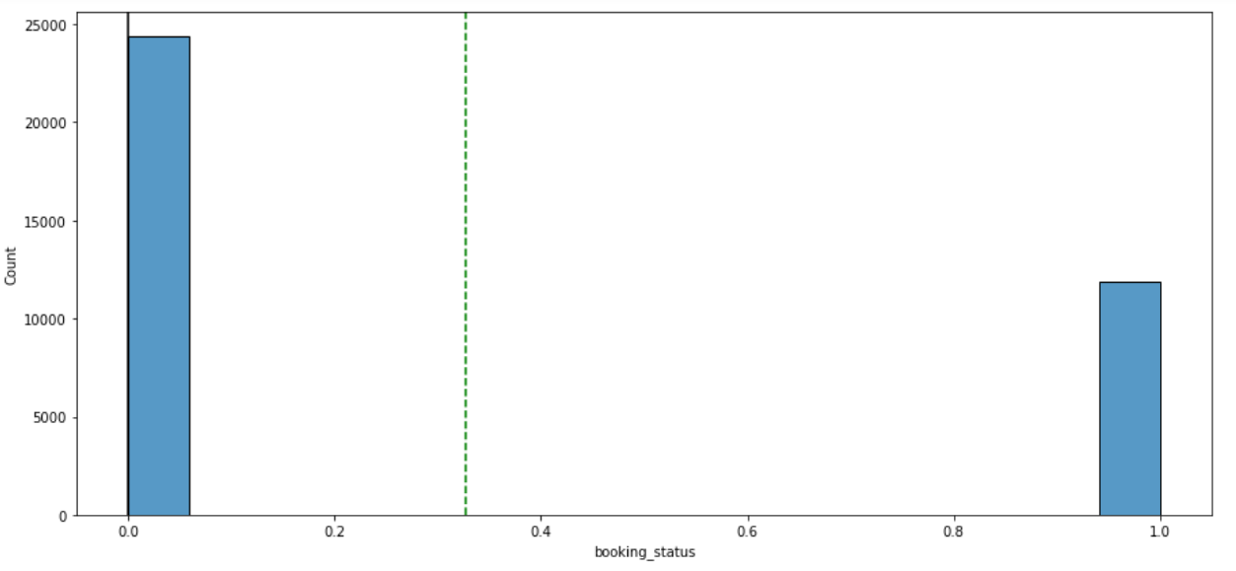

Observations:
- The booking status of being canceled or not seems to happen often enough that it does not create outliers. This shows an alarming truth to the high amount of cancellations received by the hotels.
Refer Jupyter notebook for Heat Map

Observations
- No real relationship with booking status, besides lead time.
- market_segment_Offline and market segment_Online are strongly negatively correlated.

Model performance evaluation

Model criteria
- The hotel loses money when the model predicts someone to not cancel, but does end up canceling. Since canceling is 1(positive), then we must reduce the amount of false negatives. Thus, it is best to focus on reducing the recall value.

Overall Model Comparison
- The decision tree model is better in all performance metrics.
  - Decision Tree beats the Logistic Regression model Accuracy score by 0.08.
  - Decision Tree beats the Logistic Regression model Recall score by 0.03.
  - Decision Tree beats the Logistic Regression model Precision score by 0.17.
  - Decision Tree beats the Logistic Regression model F1 score by 0.1.
- The decision tree is the predictive model that should be used as it wins in all metrics. It will provide the best predictive booking status so that hotels can correctly predict when customers will cancel

• Recommendation:

Encourage customers to choose meal plans at the time of booking by offering

discounts or bundling services. This could potentially reduce cancellations as

customers become more committed to their reservations.

• Stricter Cancellation Policies:

Implement stricter cancellation policies for high-risk bookings, such as those with long lead times or made through channels with higher cancellation rates. This can include non-refundable deposits or shorter cancellation windows.

• Incentives for Early Confirmation:

Offer incentives like discounts or room upgrades for guests who confirm their bookings early or choose non-refundable options.

• Improve Customer Experience:

Focus on improving aspects of the stay that are important to guests, such as fulfilling special requests, to reduce the likelihood of cancellations.

Actionable Insights & Recommendations

• Observation:

The Logistic Regression and Decision Tree models show moderate accuracy in predicting cancellations, but overall, the Naive Bayes model performs best. A possible reason could be that certain variables, such as lead time, have a significant impact on cancellations. Typically, longer lead times may lead to higher cancellation rates, as customers' plans may change more often with more time between booking and arrival.

• Recommendation:

The hotel can consider stricter cancellation policies for bookings made with long lead times or offer incentives for early non-refundable bookings to reduce cancellations.

Impact of Booking Lead Time on Cancellations

Observation: The Logistic Regression and Decision Tree models show moderate accuracy in predicting cancellations, but overall, the Naive Bayes model performs best. A possible reason could be that certain variables, such as lead time, have a significant impact on cancellations. Typically, longer lead times may lead to higher cancellation rates, as customers' plans may change more often with more time between booking and arrival.

Recommendation: The hotel can consider stricter cancellation policies for bookings made with long lead times or offer incentives for early non-refundable bookings to reduce cancellations.

How Special Requests Might Indicate Customer Satisfaction

• Observation:

The analysis showed a relationship between the number of special requests and cancellations. Customers who make special requests may have higher expectations, and if these expectations are not met, they might be more likely to cancel. However, this feature did not show a strong predictive power in the models, suggesting it might not be the most significant factor in cancellation prediction.

• Recommendation:

The hotel should ensure that special requests are noted and fulfilled whenever possible, as this can reduce the likelihood of cancellations and improve customer satisfaction. Additionally, understanding common requests could help the hotel proactively offer similar amenities to other guests.

How Special Requests Might Indicate Customer Satisfaction

Observation: The analysis showed a relationship between the number of special requests and cancellations. Customers who make special requests may have higher expectations, and if these expectations are not met, they might be more likely to cancel. However, this feature did not show a strong predictive power in the models, suggesting it might not be the most significant factor in cancellation prediction.

Recommendation: The hotel should ensure that special requests are noted and fulfilled whenever possible, as this can reduce the likelihood of cancellations and improve customer satisfaction. Additionally, understanding common requests could help the hotel proactively offer similar amenities to other guests.

Effect of Meal Plan Selection on Cancellation Likelihood

• Observation:

Meal plan selection might be an indicator of customer commitment to their booking. Guests who select a full or half-board meal plan might be less likely to cancel, as they have invested more in the stay. This was reflected in the data, though it wasn't the strongest predictor

• Recommendation:

Encourage customers to choose meal plans at the time of booking by offering discounts or bundling services. This could potentially reduce cancellations as customers become more committed to their reservations.

Insights and Recommendations
- The greater the lead time the greater the chance a cancellation will occur. Thus, there should be policies stating that a booking made as far out as about 150-200 days should be given an extra non-refundable fee to ensure they do not cancel.
- Since cancellation only occurs at a rate of 1.3% when the booking is made by a repeated guest, repeated guest should get special rewards. A membership receiving free stays after a certain amount of stays, based on a points system, would be a good option. The reservation fee on long lead times may be waived as well.
- Online reservations make up 64% of the reservations, they also have the highest rate of cancellations compared to other market segment types. They have a cancellation rate of almost 35% of the time. Thus, there should be an extra premium attached to online reservations.
- If someone has previously cancelled a booking they are 96% sure to not cancel a booking again.
- If someone has not previously canceled a booking but they have booked a reservation before, then they are sure to not cancel.
- It can be concluded that most cancellations happen with first time users. Thus, repeat customers will help drastically reduce the number of cancellations. Attracting repeat customers with promos and discounts will help decrease cancellations, as the repeat customer almost never cancels.

